**CODE COVERAGE PREDIKSIGAJI_2**

1. **CODE COVERAGE FOLDER PREDIKSI**
   1. 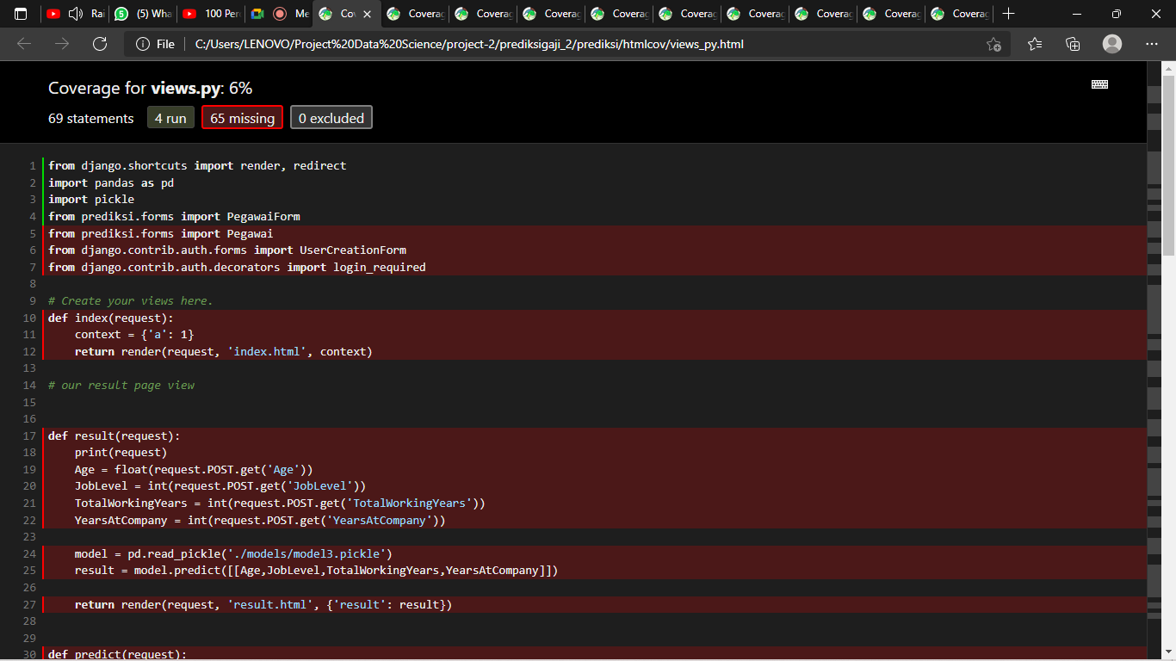 Views
   2. 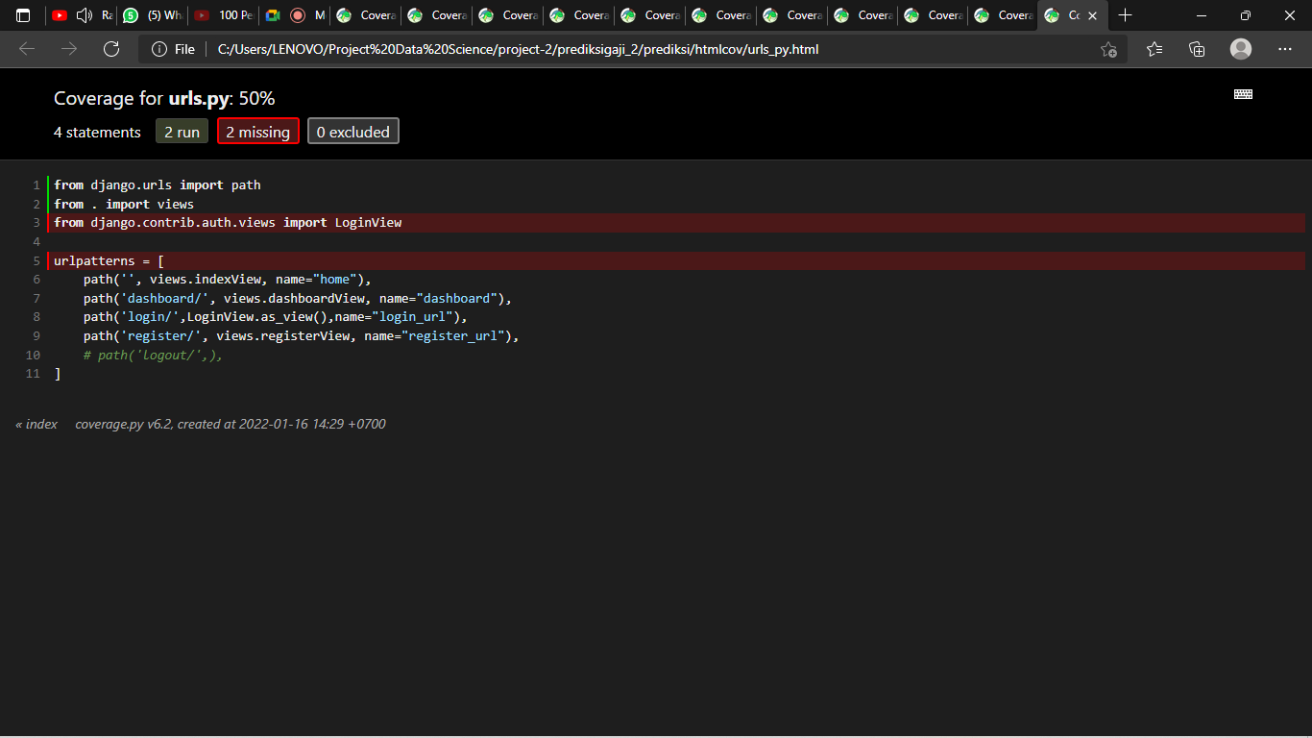 Urls
   3. 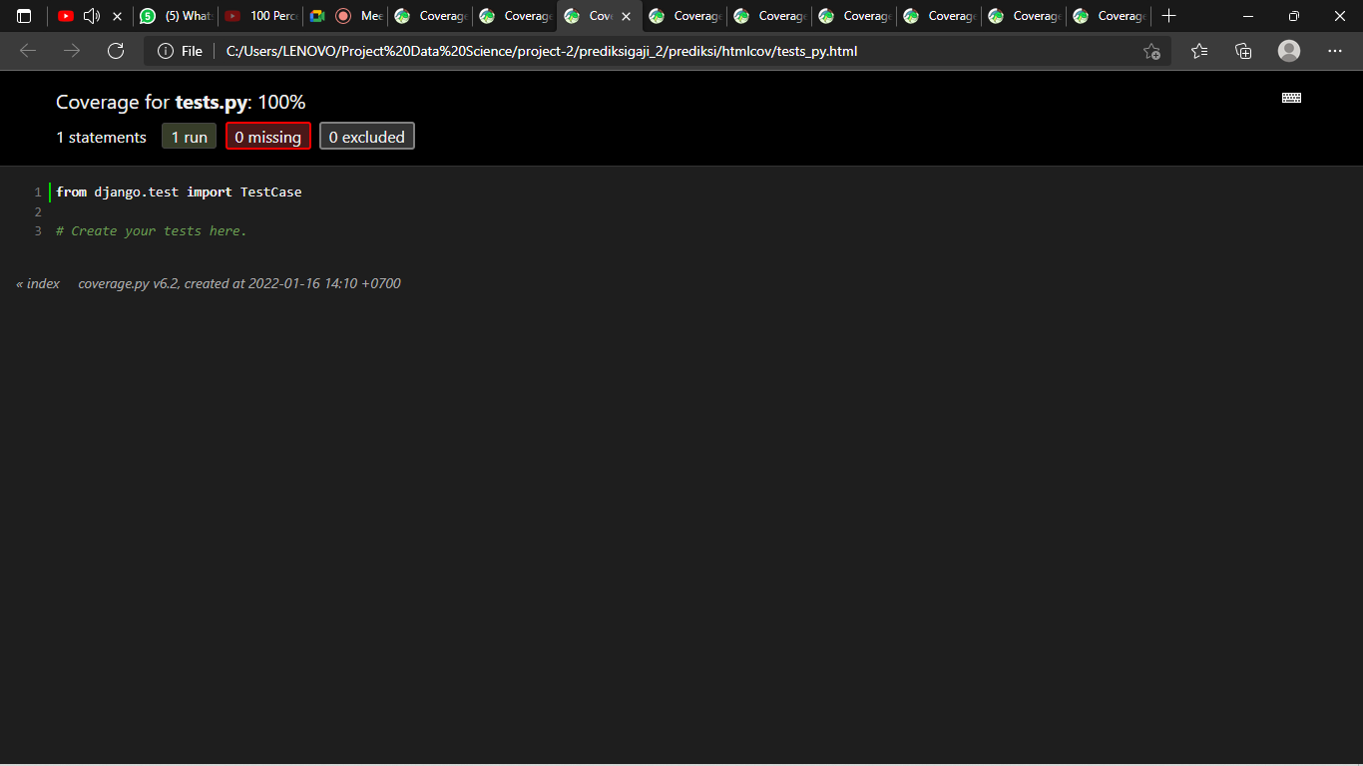 Tests
   4. 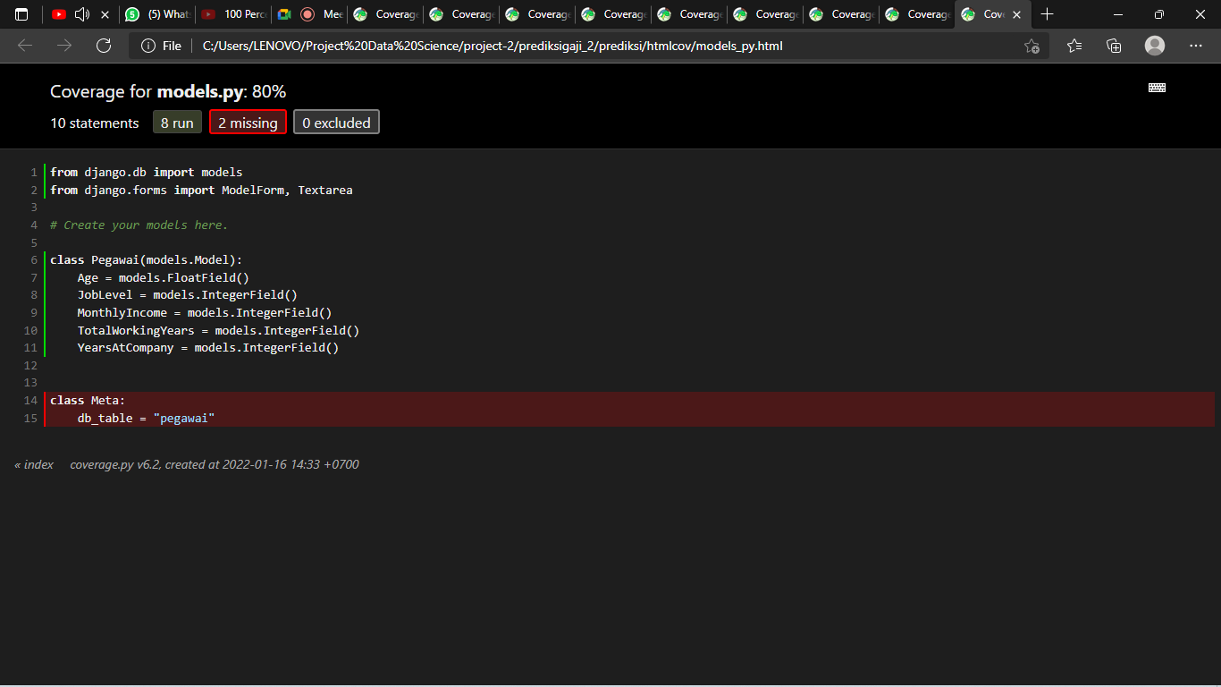 Models
   5. 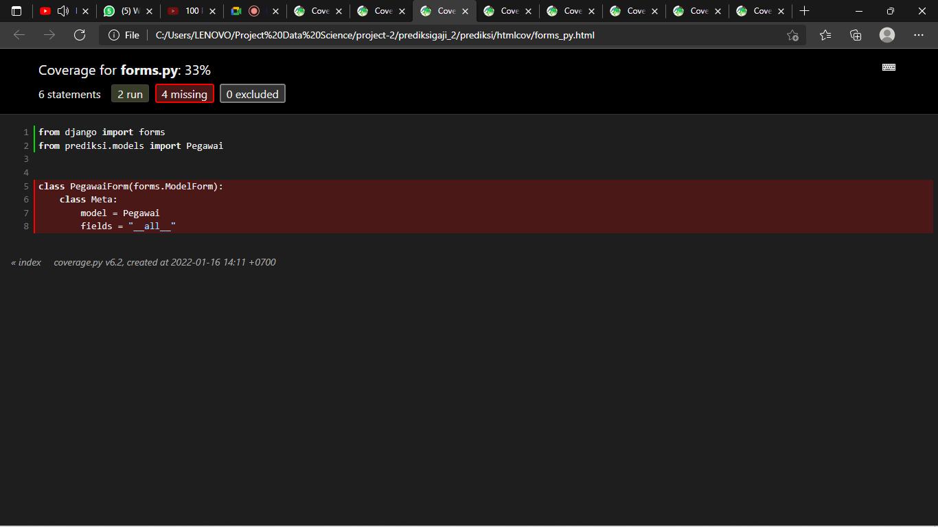 Forms
   6. 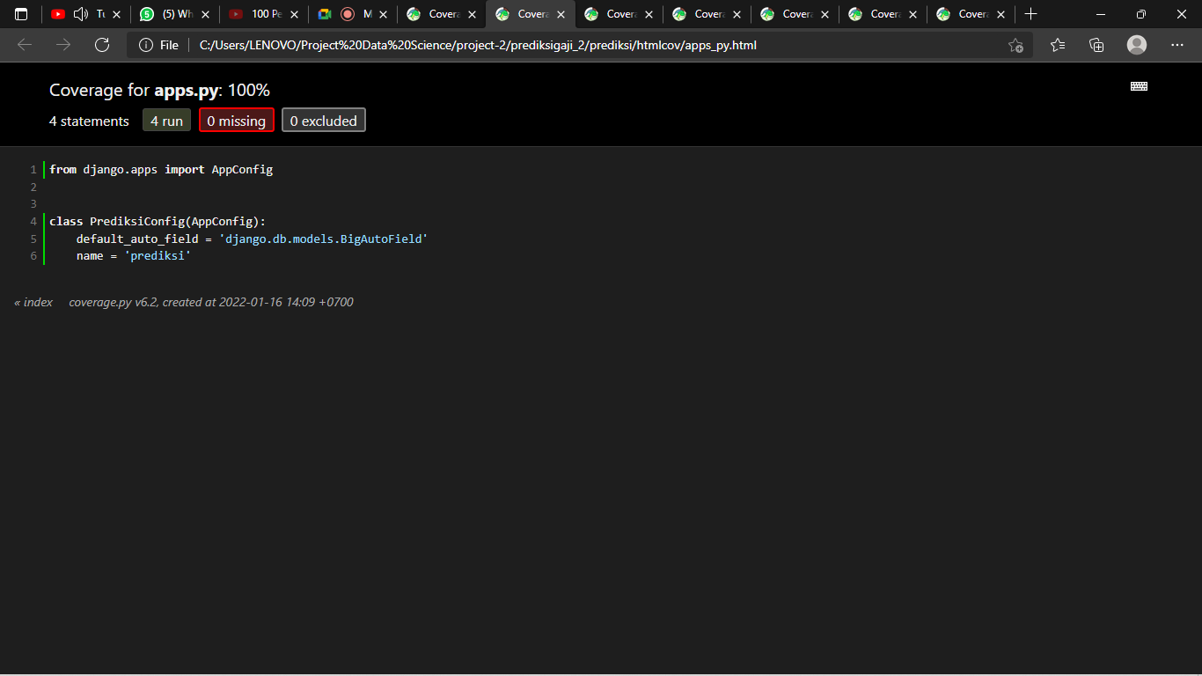 Apps
   7. 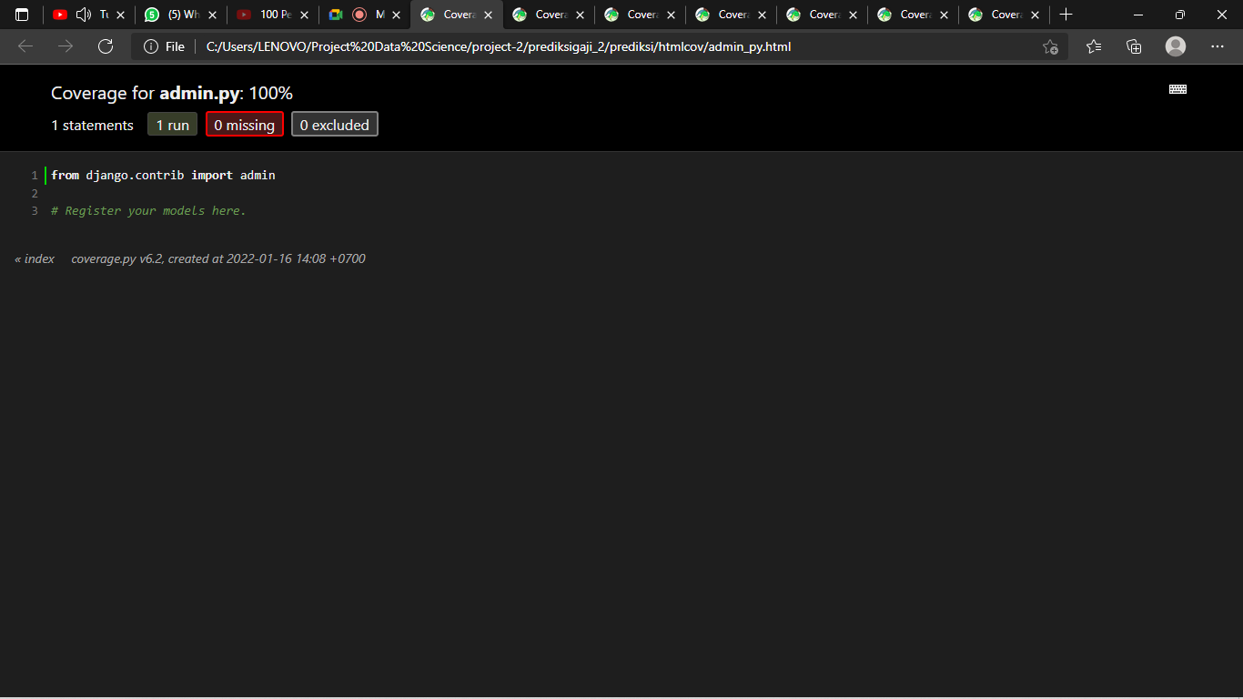 Admin
2. **CODE COVERAGE FOLDER PREDIKSIGAJI**
   1. 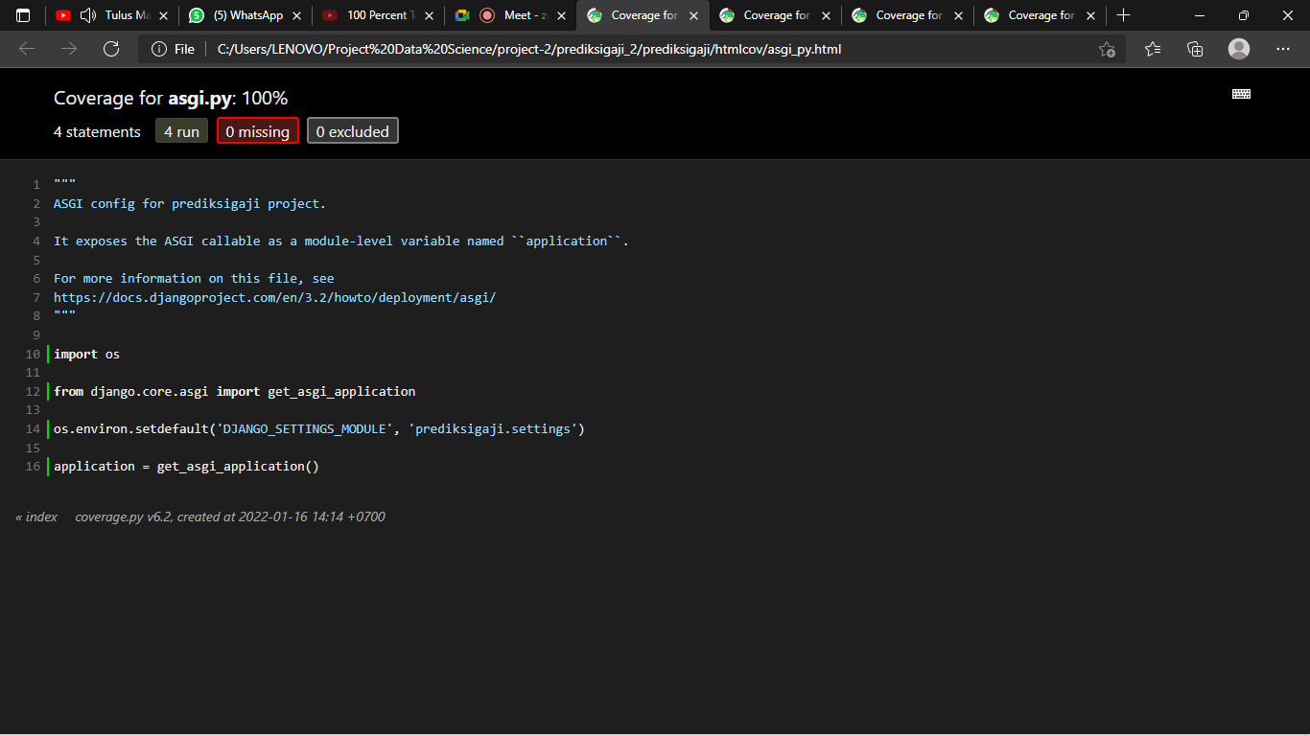 Asgi
   2. 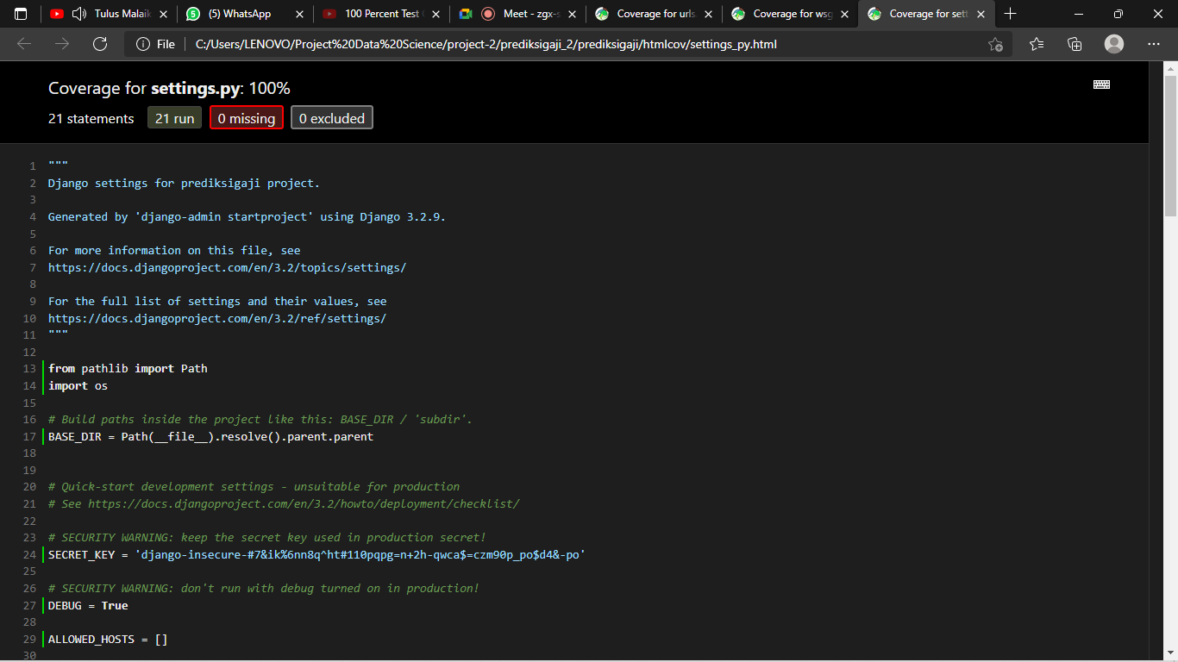 Settings
   3. 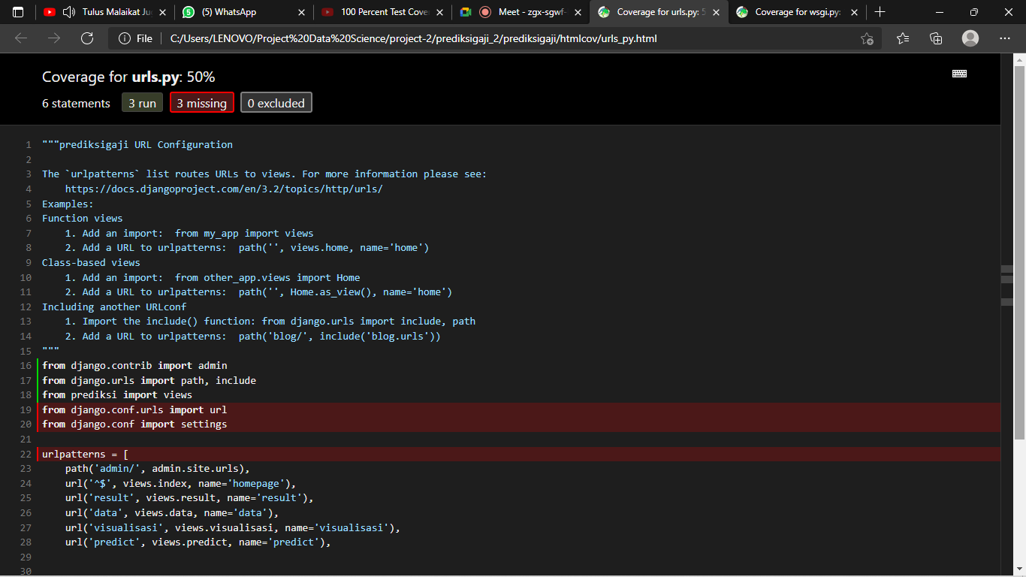Urls
   4. 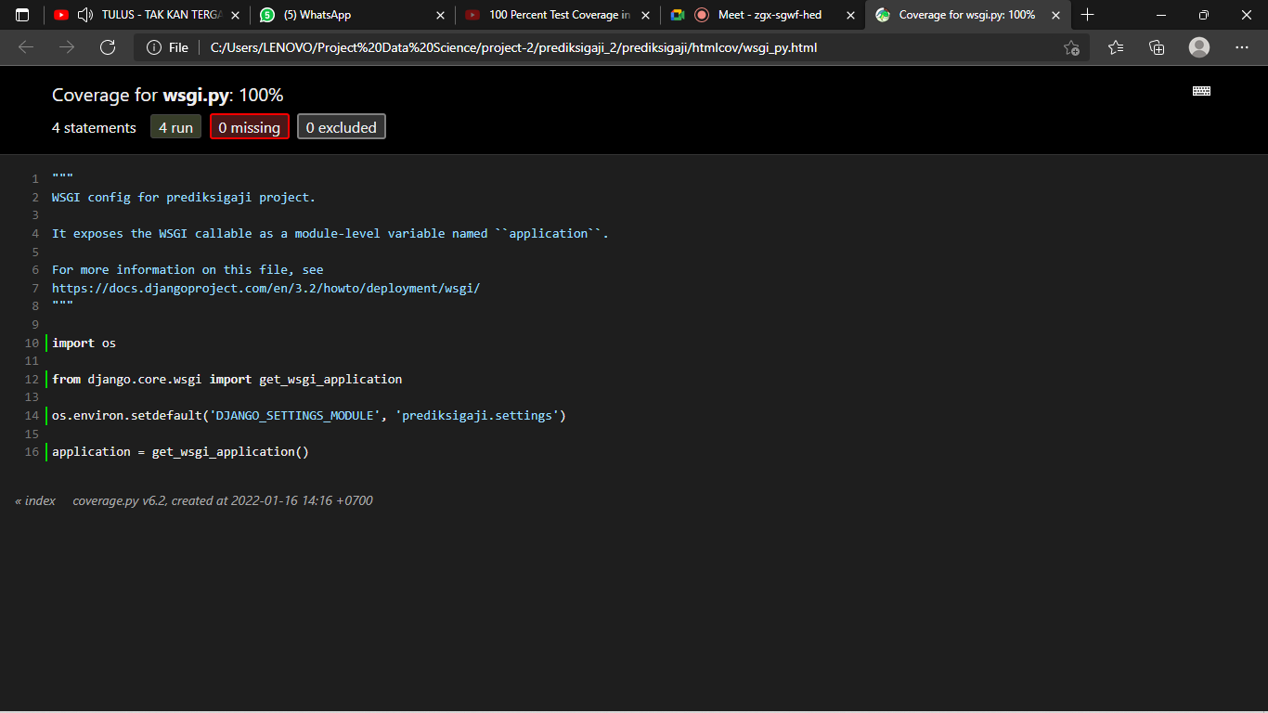 Wsgi